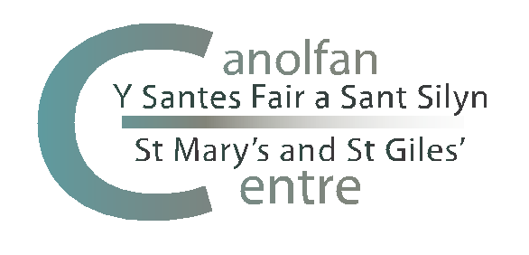

The St Mary’s Centre Annual Symposium
in Practical Theology and Religious Education
12-14 November 2019
at Noddfa, Penmaenmawr

The 2019 St Mary’s Centre Annual Symposium will begin with lunch at around 12.30pm on Tuesday 12 November 2019 and close after lunch on Thursday 14 November 2019.

LOCATION

The Symposium will be held at:

Noddfa, Conwy Old Road, Penmaenmawr, North Wales LL34 6YF
(website: www.noddfa.org.uk)

HOW TO GET THERE

- By train: Penmaenmawr is on the Chester-Holyhead route. Some trains stop (by request) at Penmaenmawr otherwise the nearest station is Llandudno Junction. Taxis are available from Llandudno Junction. Penmaenmawr Station is about one mile from Noddfa. (It is possible for a member of staff to meet you at Penmaenmawr Station but this will need to be arranged in advance.)

- By car: Leave the A55 at the roundabout signed for Penmaenmawr (Junction 16). Follow the road as far as the Mountain View Hotel. Take a sharp left into Conwy Old Road. Continue for 0.5 mile. The entrance to Noddfa is on the right opposite Tan-y-Foel cemetery.

PRESENTATIONS

All participants are encouraged to offer a presentation, either for:

- a seminar of about 60 minutes to present research findings (presentation of no more than 40 minutes followed by discussion)
- a seminar of about 30 minutes to present research plans (presentation of no more than 15 minutes followed by discussion)

Please note the distinction between the two types of presentation. Participants are also usually asked to chair a session.

ABSTRACTS

Please indicate your intention to offer a presentation on the booking form and forward an abstract by email to leslie.francis@warwick.ac.uk by 30 September 2019. No papers or abstracts will be accepted after this date.

BOOKING

Please complete the booking form and return with your payment by 30 September 2019. We need to be able to confirm numbers with Noddfa at this time.

COST

The full residential cost for the Symposium is £150.00. This includes accommodation and all meals. On-site places are limited to 30 participants but there are additional bed and breakfast options nearby.

Places are also available on a non-residential basis and costs (covering meals and refreshments) for the Symposium are:

- £45.00 for Tuesday 12 November 2019
- £45.00 for Wednesday 13 November 2019
- £20 for Thursday 14 November 2019
- £90 for the full Symposium on a non-residential basis

PAYMENT

Payment may be made by:

- Bank transfer to:

Sort Code: 20-25-69
Account No: 63617513
Account Name: The St Mary’s and St Giles Centre

Please quote your name and ‘Symposium’ as a reference and forward your completed booking form by email to emma.eccles@bishopg.ac.uk

OR

- Cheque: Please make your cheque payable to ‘The St Mary’s and St Giles’ Centre’ and forward together with your completed booking form to:

Mrs Emma L. Eccles
The St Mary’s Centre
Llys Onnen
Abergwyngregyn
Llanfairfechan
Gwynedd LL33 0LD

FURTHER INFORMATION

If you require any further information please contact Mrs Emma L. Eccles:

- emma.eccles@bishopg.ac.uk

01248 680131

The St Mary’s Centre, Llys Onnen, Abergwyngregyn, Llanfairfechan LL33 0LD

